**Customer Appointment Schedule**

**Technologies Used:**

Front-End: HTML5, CSS3, Bootstrap, AngularJS & Javascript

Data Access Layer: Hibernate

Database: MySQL

Back-End: Java & Spring MVC

**Project Screenshots:**

**Home Screen**

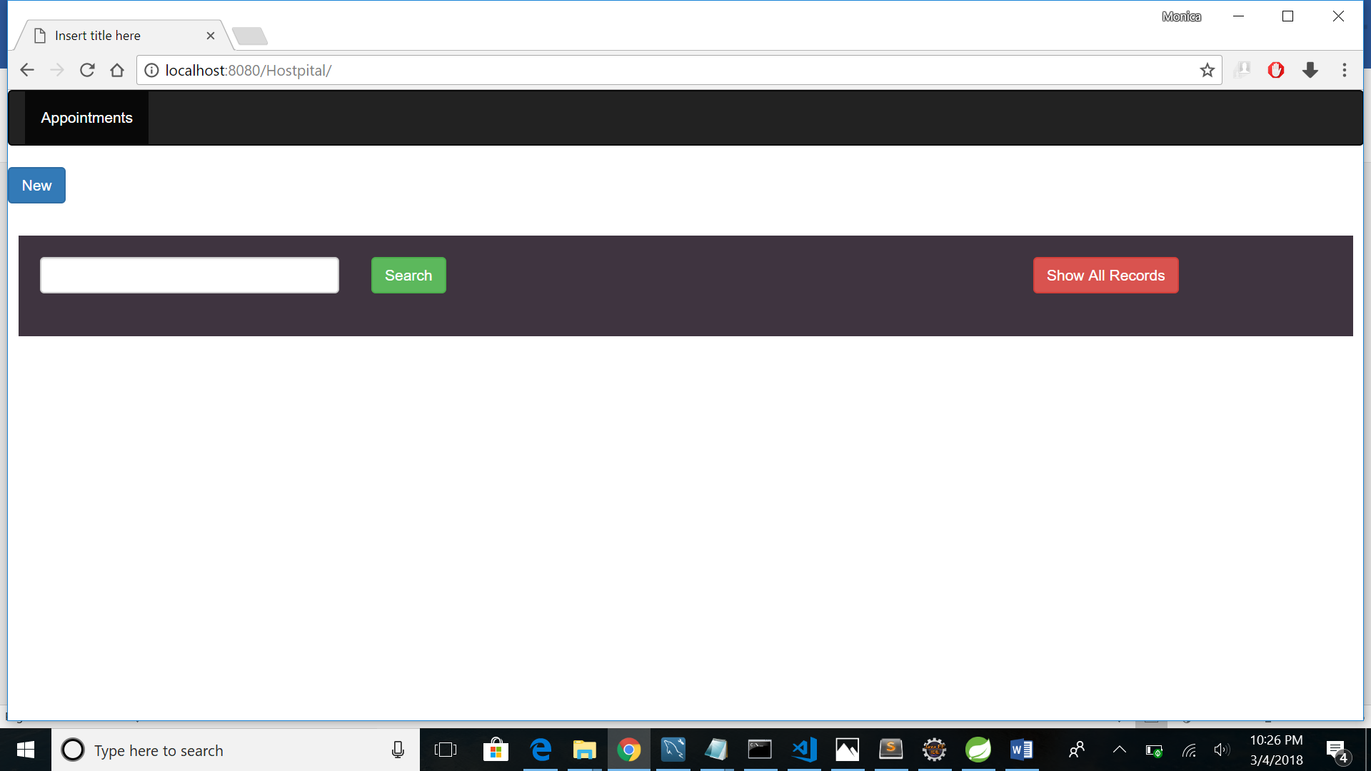

**Creating New Record upon clicking “New” Button**

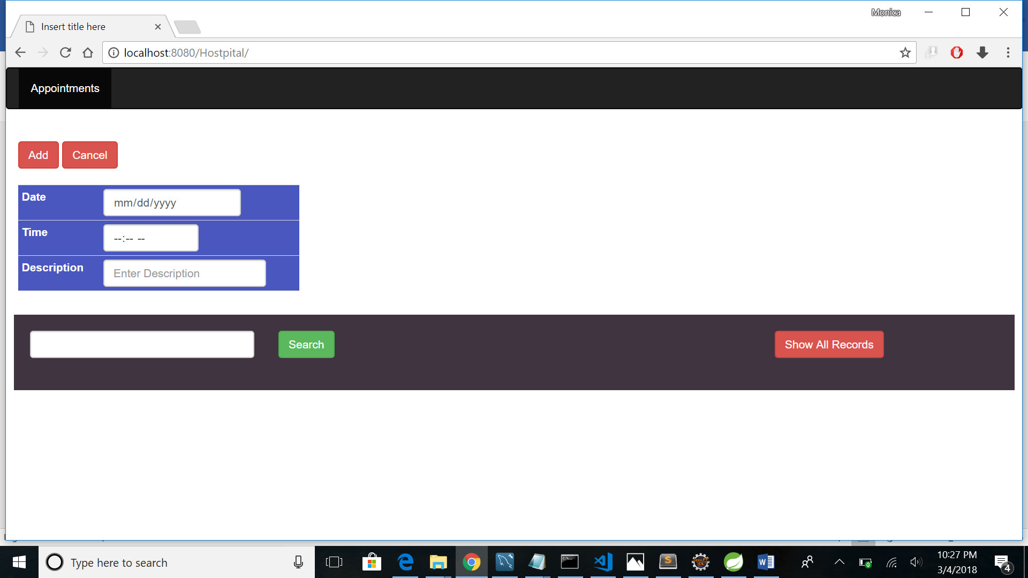

**Adding Records to the Database upon clicking on “Add” button**

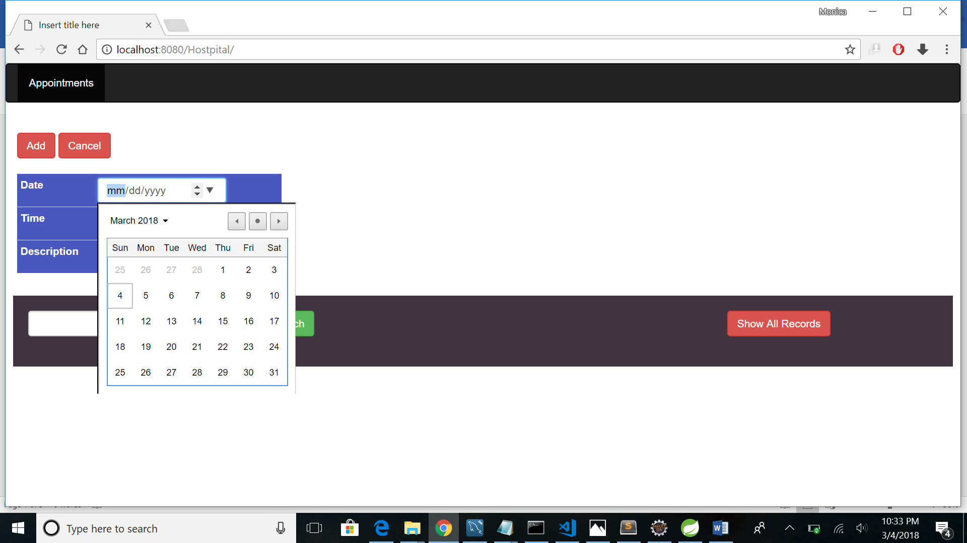

**Fetching Record through AJAX**

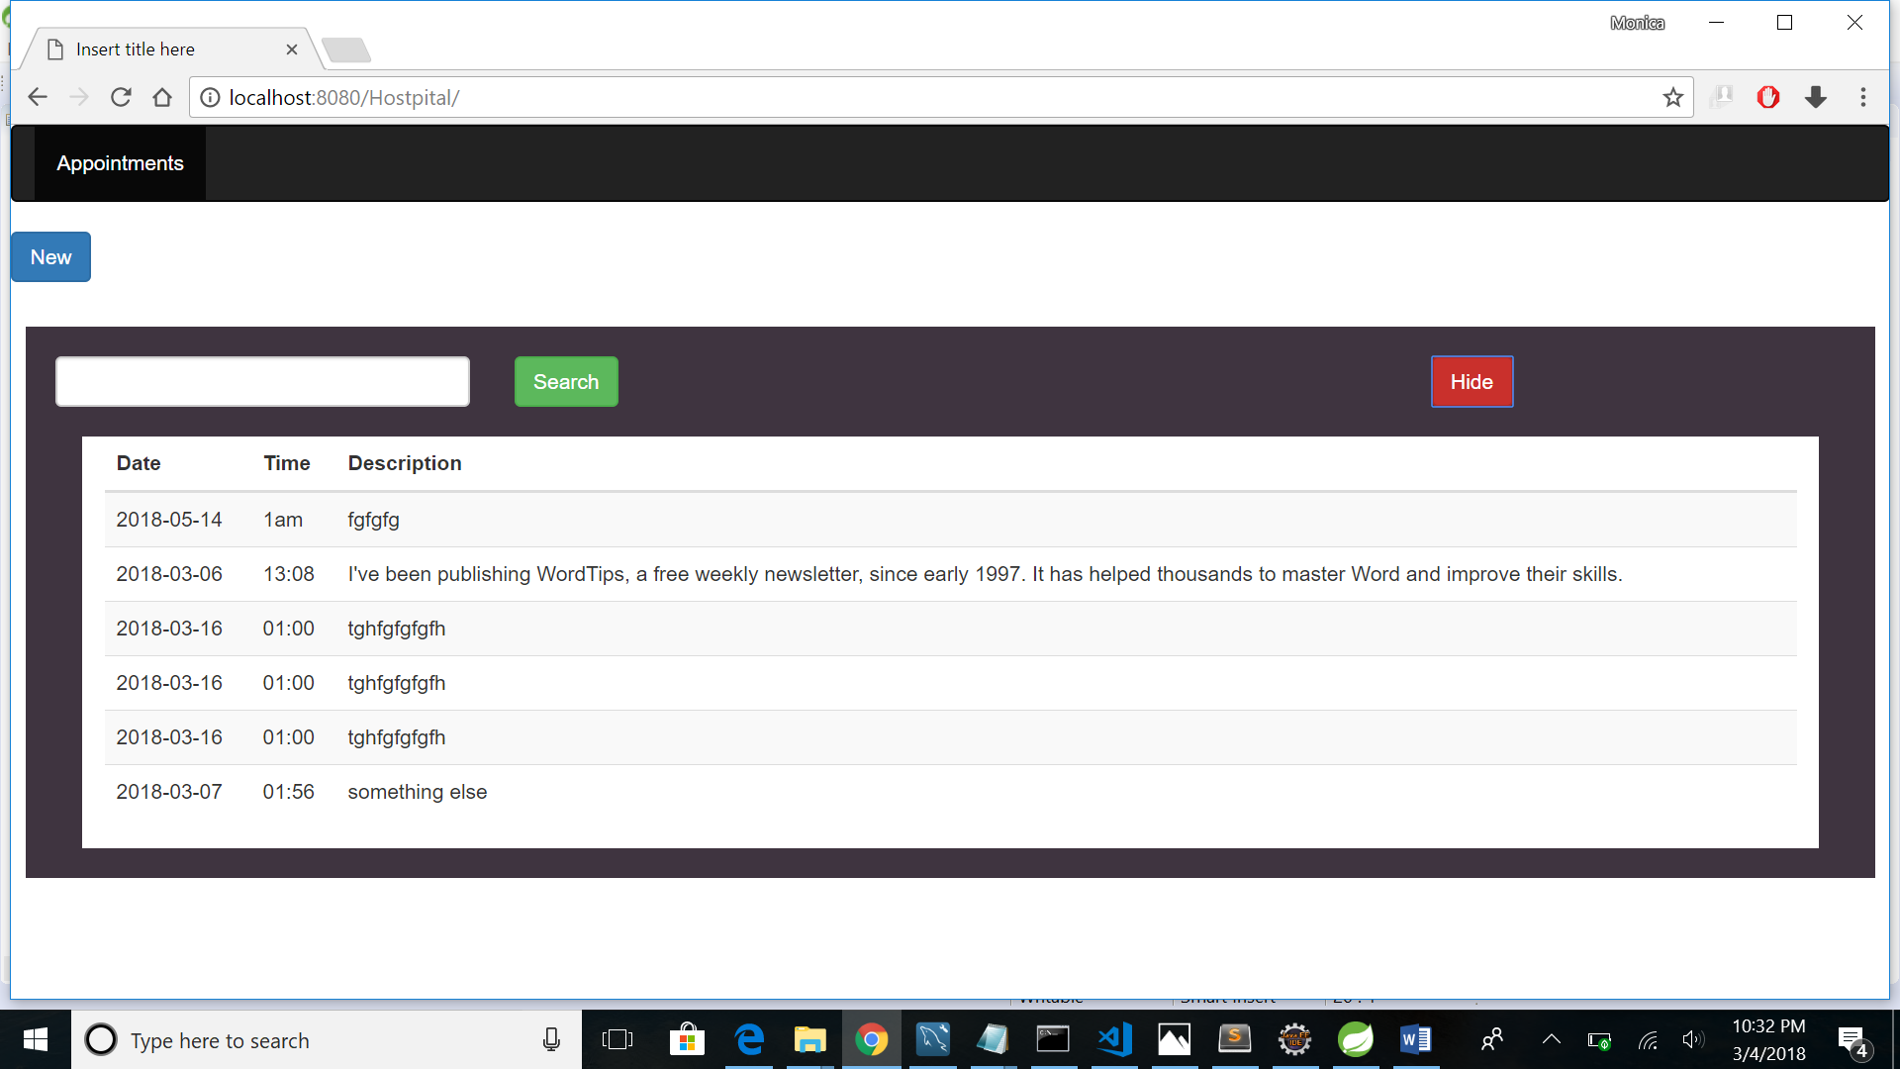

**This is MySQL Screen where Customer Records are persisted**

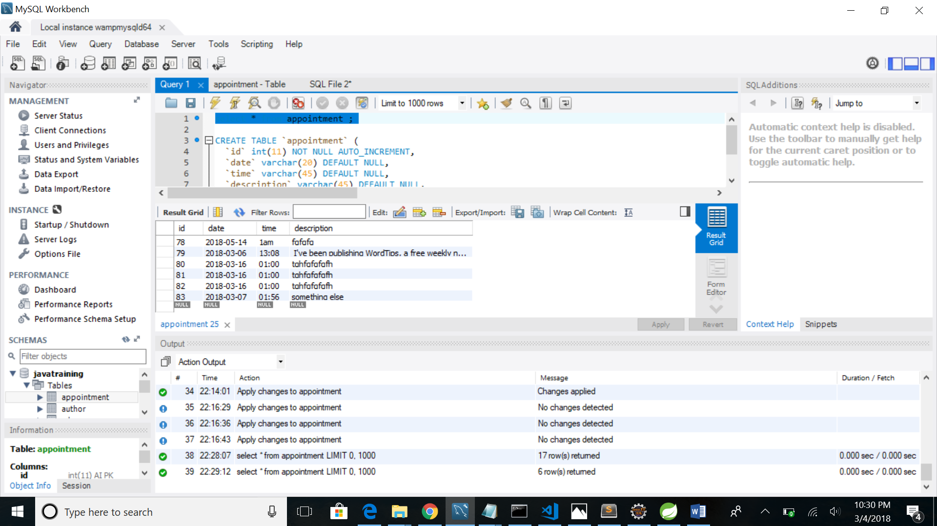

**This is the Folder Structure in IDE**

